

CAR

PORSCHE 944 S2 cabriolet

Production
1991

DRIVERS

Nico and Pia

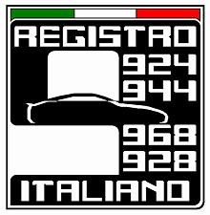R.I.T.
Italian transaxle Register

