5204-2RS X 15/16

Dimensions (metric) | d | 20 | 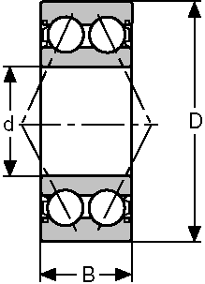  Two Seals 2RS
Dimensions (metric) | D | 47
Dimensions (metric) | B | 23.8
Approx.  Wgt. lbs |  | .396
1) This series is Conrad design (no filling slot) angle of contact 25°.

